Lab_3
Report

Qianchao Wang
Qijia He
(a) git log

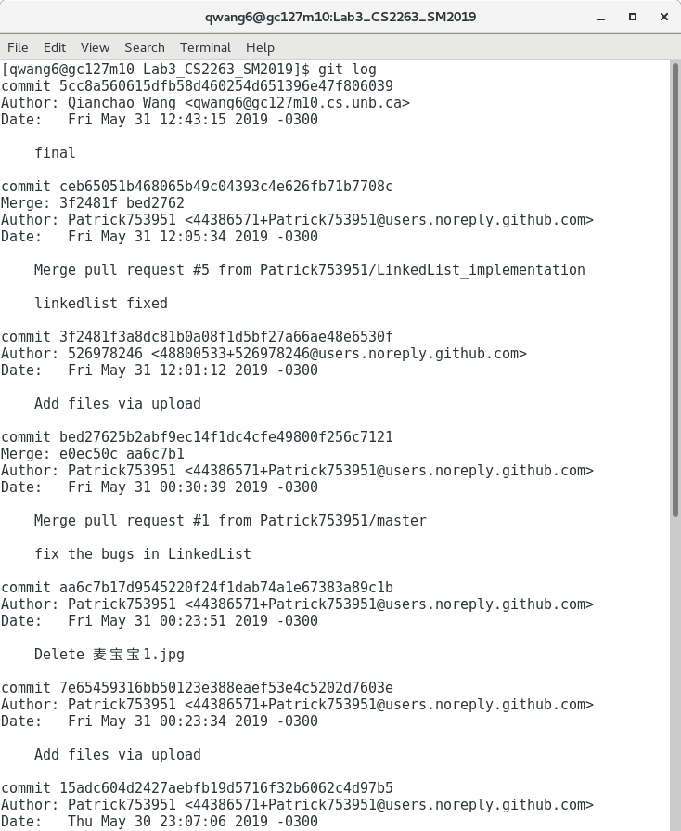
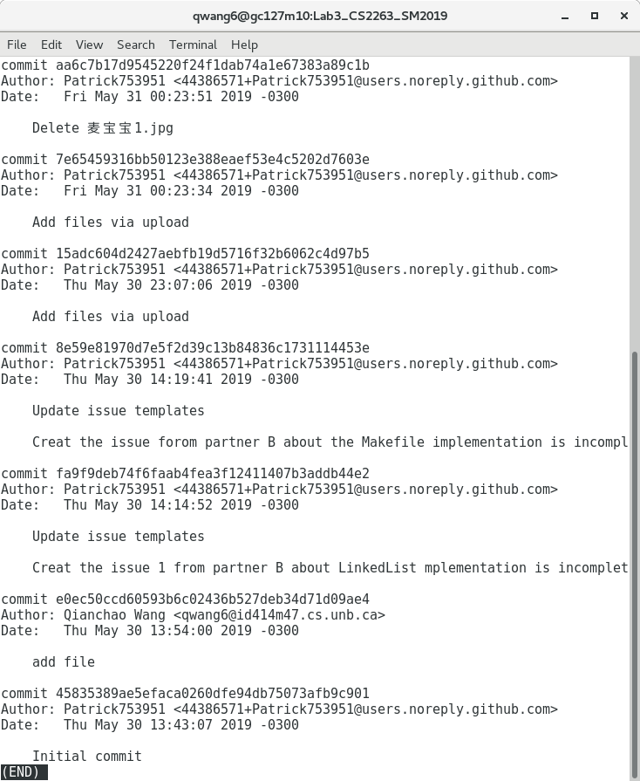
(b) pull request

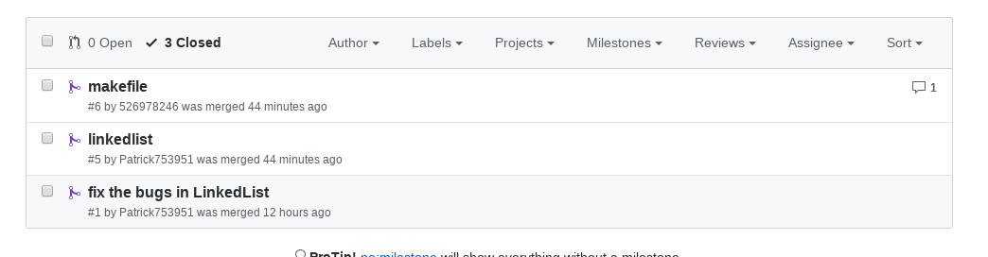
(c) closed issue

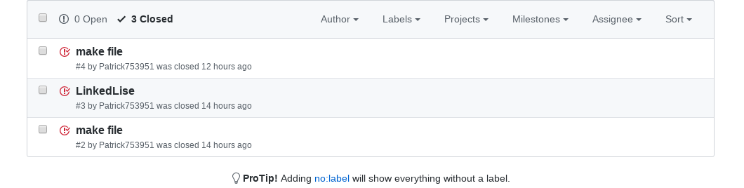
(d) test

